Exp-12

/\*WAP: Write a program in java to find Largest between two number using packages.\*/ //Khan Arman Riyaz //231P072,13 package compare;

public class Largest {

public int findLargest(int a, int b) {

if (a > b) { return a;

} else {

return b;

}

}

}

//The file using the above package import compare.Largest; import java.util.Scanner;

public class CompareNumbers {

public static void main(String[] args) {

Scanner sc = new Scanner(System.in);

// Prompt user for two numbers System.out.print("Enter the first number: "); int num1 = sc.nextInt(); System.out.print("Enter the second number: "); int num2 = sc.nextInt();

// Create an object of the Largest class from the compare package

Largest largest = new Largest();

// Find and print the largest number int result = largest.findLargest(num1, num2);

System.out.println("The largest number is: " + result);

}

}

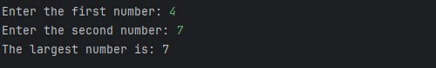

//WAP: Write a program in java to add two number using packages.

//Khan Arman //231P072,13 package addNumber;

public class Add {

// Method to add two integers public int add(int a, int b) { return a + b;

}

}

//Code which uses this package import addNumber.Add; import java.util.Scanner;

public class addNumbers {

public static void main(String[] args) {

Scanner sc = new Scanner(System.in);

System.out.println("Enter number 1: "); int num1 = sc.nextInt();

System.out.println("Enter number 2: "); int num2 = sc.nextInt();

// Create an instance of the Add class

Add adder = new Add(); // Corrected this line

// Call the add method to get the sum

int result = adder.add(num1, num2); // Corrected this line

System.out.println("The result is: " + result);

}

}

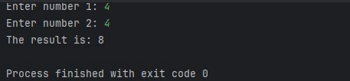

//WAP:Write a program in java to compute factorial of a number using package.

//Khan Arman //231P072,13 package factorialCalculator;

public class Factorial {

public long calculateFactorial(int n) { if (n < 0) {

throw new IllegalArgumentException("Factorial is not defined for negative numbers.");

}

long factorial = 1; for (int i = 1; i <= n; i++) { factorial \*= i;

}

return factorial;

}

}

//File using the above package import factorialCalculator.Factorial; import java.util.Scanner; public class FactorialMain { public static void main(String[] args) {

Scanner scanner = new Scanner(System.in);

// Prompt user for a number

System.out.print("Enter a number to calculate its factorial: "); int number = scanner.nextInt();

// Create an instance of the Factorial class

Factorial factorialCalculator = new Factorial();

// Calculate and display the factorial

try {

long result = factorialCalculator.calculateFactorial(number);

System.out.println("The factorial of " + number + " is: " + result);

} catch (IllegalArgumentException e) {

System.out.println(e.getMessage());

}

}

}

